**Project Report Template**

1. **Introduction :**
   1. **Overview :**

**\*Visit Canva’s website or use the Canva app on your device.**

**\*click on “Create a design” and select the “Custom dimensions” option. For YouTube thumbnails, the recommended size is 1280 x 720 pixels.**

**\*You can start from scratch or use one of Canva’s thumbnail templates. Search for “YouTube thumbnail” to find suitable templates.**

**1.2 Purpose:**

**\*The purpose of a YouTube thumbnail is to attract viewers’ attention and encourage them to click on your video.**

**\*A well-designed thumbnail can convey the content, tone, and quality of your video, making it more likely that people will choose to watch your content.**

1. **Problem Definition & Design Thinking:**
   1. **Empathy map:**

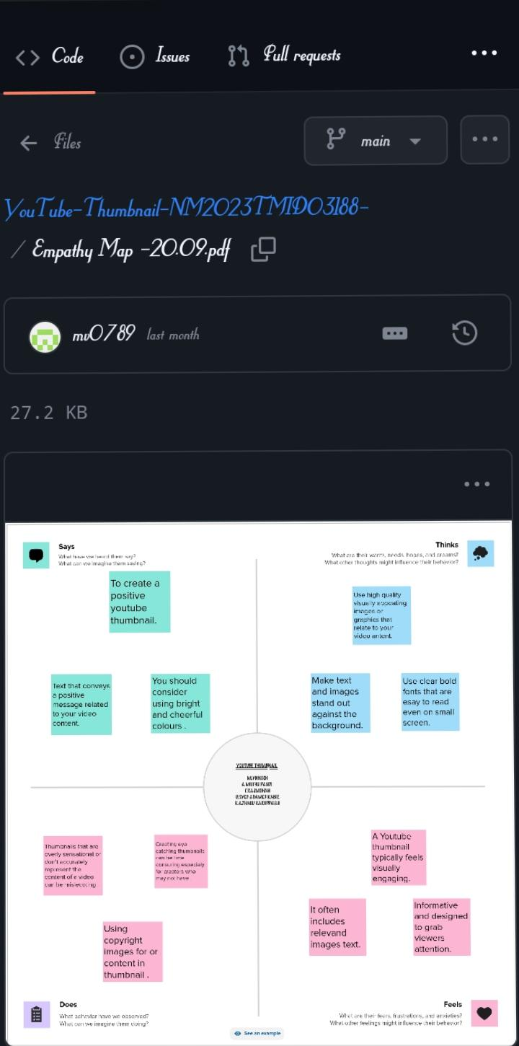

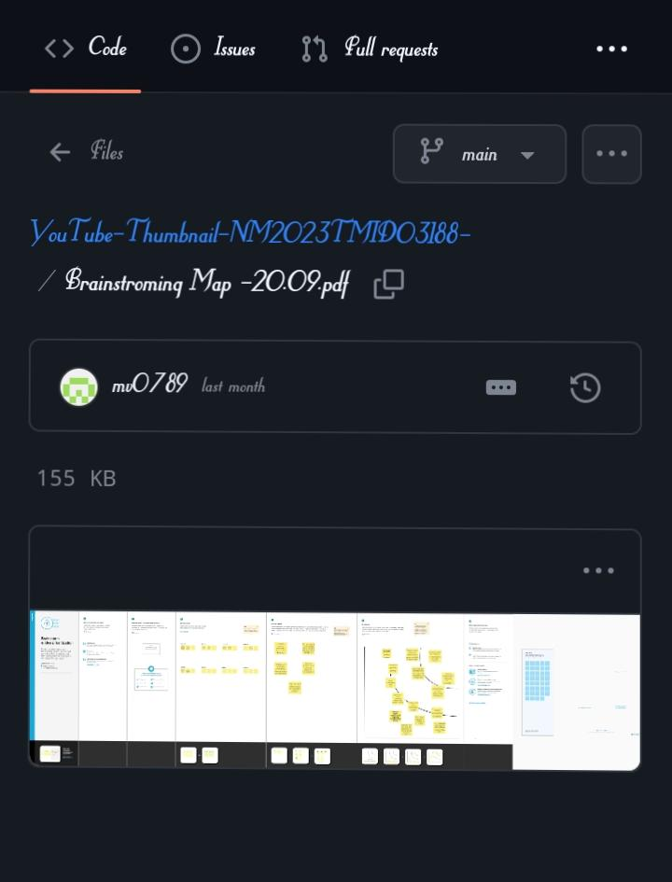

**2.2 Ideation & Brainstorming Map:**

**3. Results :**

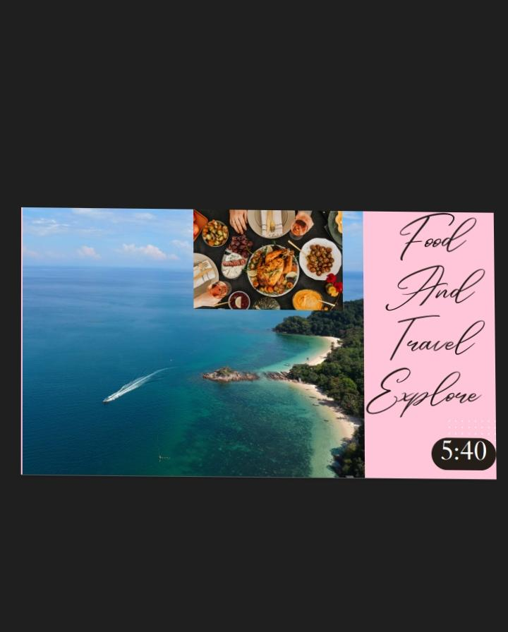**PNG FILE**

**PNG FILE LINK :**

<https://www.canva.com/design/DAFxZTKkoGk/PP9wbpGLZTisBTPruu0i0w/view?utm_content=DAFxZTKkoGk&utm_campaign=share_your_design&utm_medium=link&utm_source=shareyourdesignpanel>

**PDF FILE :**



**PDF FILE LINK:**

<https://www.canva.com/design/DAFxZTKkoGk/PP9wbpGLZTisBTPruu0i0w/view?utm_content=DAFxZTKkoGk&utm_campaign=share_your_design&utm_medium=link&utm_source=shareyourdesignpanel>

**DEMO VIDEO LINK:**

<https://drive.google.com/file/d/1HEqHLc78LC_A87NaOKVyD5490vPP_v00/view?usp=drivesdk>

**4.Advantages& Disadvantages:**

**Advantages:**

**\*Engaging and eye-catching thumbnails can entice viewers to click on your video, increasing your click-through rate.**

**\*Thumbnails provide a snapshot of what the video is about, helping viewers understand the content before clicking.**

**\*Consistent thumbnail design can reinforce your channel’s branding and make your videos easily recognizable.**

**Disadvantage:**

**\*Thumbnails can be misleading, leading to viewer disappointment if the content doesn’t match the thumbnail’s promise.**

**\*The sheer volume of videos on YouTube makes it challenging to create a unique, attention-grabbing thumbnail.**

**\*Thumbnails should be visually appealing and readable on various screen sizes, which can be challenging.**

1. **Applications:**

**\*Canva is a popular online tool for creating YouTube thumbnails.**

**\*You can use Canva’s YouTube Thumbnail templates to design custom thumbnails with text, images, and graphics. Just visit Canva’s website, sign up or log in, and search for “YouTube Thumbnail” in the template search to get started.**

**\*Canva provides a user-friendly interface and various customization options for creating engaging thumbnails.**

**6. Conclusion:**

**\*Go to Canva and sign in or create an account if you haven’t already.**

**\*Select “Custom Dimensions” and enter the recommended YouTube thumbnail size (1280x720 pixels).**

**\*Use Canva’s design tools to add images, text, and other elements that represent your video.**

**7.FutureScope :**

**\*Canva may continue to add more advanced features and templates tailored specifically for YouTube content creators.**

**\*Deeper integration with YouTube and other platforms for seamless content creation and publishing.**

**\*Canva may incorporate AI features for automated thumbnail creation, making it easier for creators to generate eye-catching thumbnails.**

**\*Enhanced collaboration features to allow multiple creators to work on a thumbnail simultaneously.**

**\*Canva might improve its mobile apps for on-the-go content creation.**

**TEAM MEMBERS :**

**1A.MUTHU PANDI – C1A24146**

**2.M.VIGNESH – C1A28472**

**3.T.RAJ MOHAN – C1A28467**

**4.K.ALAZU KARUPPAYA –C1A28459**

**5.SYED AHAMAD KABIR – C1A28470**